FIELD TRIPS

The field trips we have been on this year have so far been very successful. A huge thank-you goes out to the Recycling Depot and The Post Office for inviting our groups into their workspace and giving us an age-appropriate tour.

The children were amazed to learn that pop bottles can be turned into material for t-shirts and milk jugs are shredded to make filling for stuffed animals.

We had the opportunity to get a sneak peek of Santa’s mailbox and we will all be writing letters to Santa to send on December 1st.

I would also like to thank all the parent volunteers who have come with us on our trips, I have enjoyed getting to know each of you and look forward to many more field trips this year.

DATES TO REMEMBER

Monday, October 24-Group 1 and 2 Post office field trip @ 2:00 p.m.

Tuesday, October 25- Group 3 Post office field trip @ 2:00 p.m.

Wednesday, October 26th- Show and Share

Thursday, October 27th- Show and Share

Monday, October 31st- Group 1 and 2 dress up Halloween Party

Tuesday, November 1st- Group 3 dress-up Halloween party

Wednesday, November 2nd- Library visit

Thursday, November 4th- Library Visit

Monday, November 7th- Remembrance Day presentation @ 10:00 a.m.

Tuesday, November 8th- Remembrance Day presentation @ 10:00 a.m.

**Thursday, November 10th- NO CLASS (make-up day on November 18th)**

Friday, November 11th- Remembrance Day

Friday, November 18th- Make up day for group 3 (Thursday class)

Thursday, November 24th- in-class visit from Veterinarian

Monday, November 28th- in-class visit from Veterinarian

Tuesday, November 29th- Show and Share

Wednesday, November 30th- Show and Share

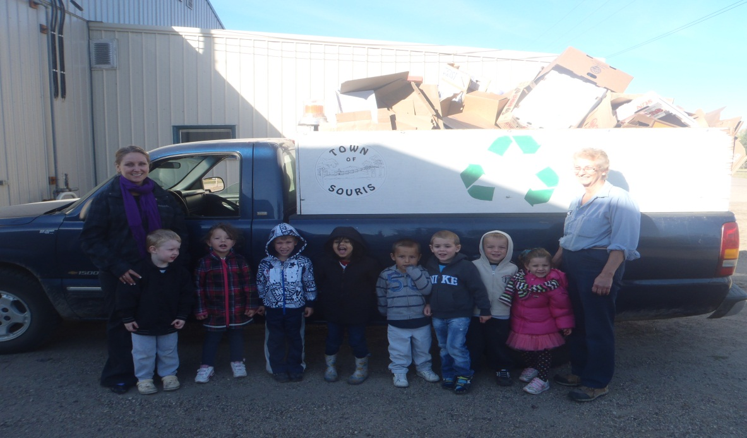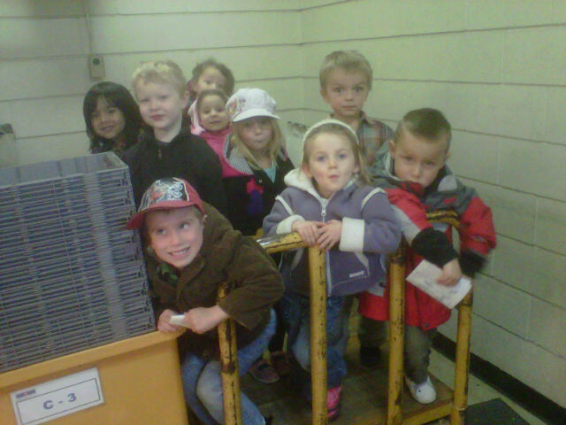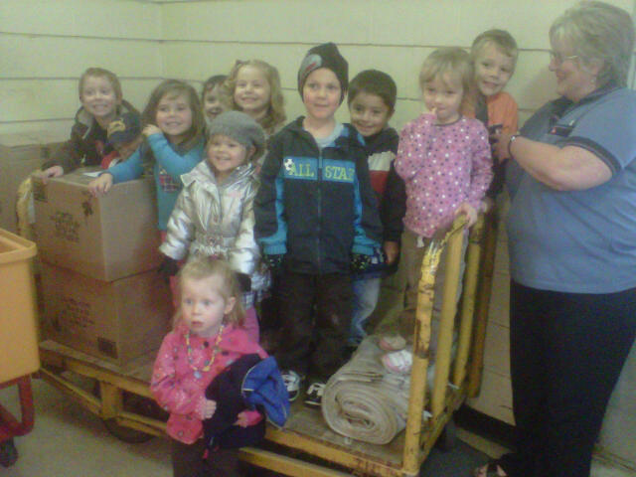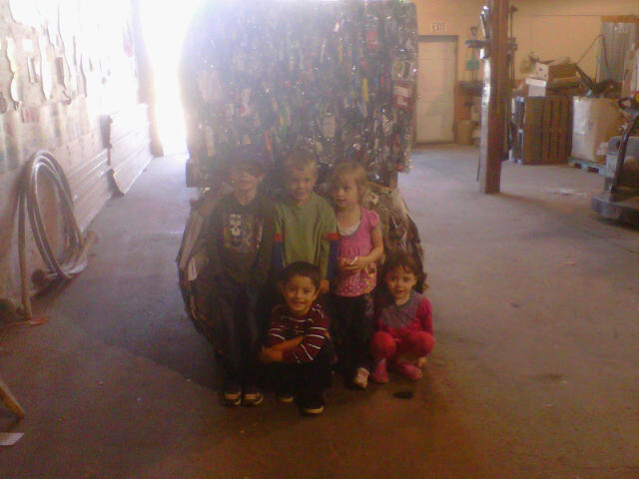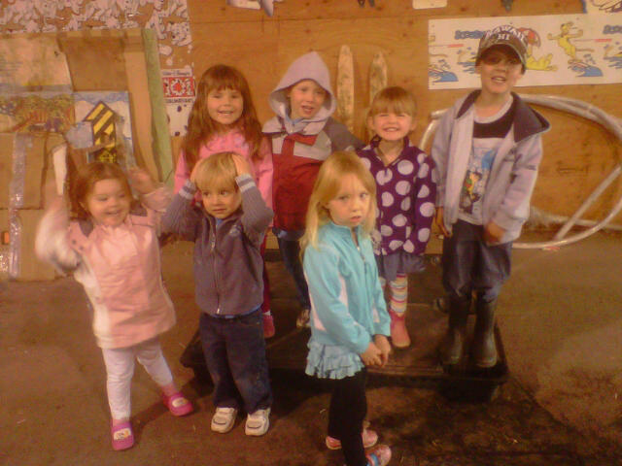

**Reduce!**

**Reuse!**

**Recycle!**

*Souris Nursery School Newsletter*

*October/November 2011*