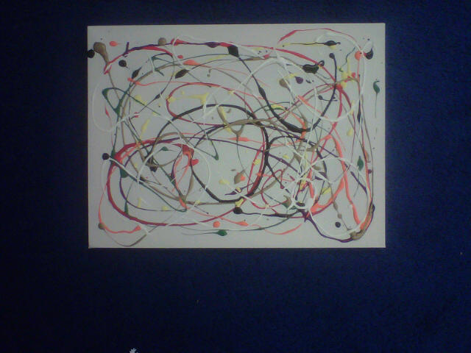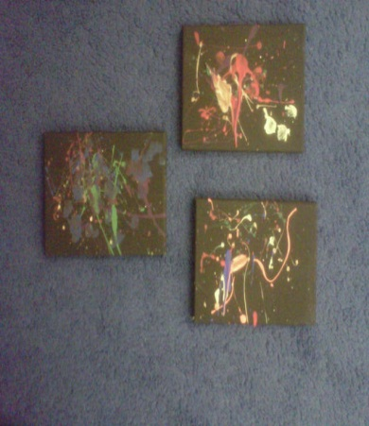

HALLOWEEN SOCIAL

Thank you to those who were able to help out with the Halloween Social on October 29th. The ticket sales, Chinese auction and Kids’ Art Auction were a huge success. Visit the daycare website at [www.growingstrong.weebly.com](http://www.growingstrong.weebly.com) to see some more samples of the art pieces submitted in the auction, which alone raised over $600.00!!

PARENT REPRESENTATIVES

I am looking for a group of Nursery School parents who would be willing to meet every few months to discuss the Nursery School program with myself and Tara Mills, the director of the Souris Day Care Programs.

We are looking to discuss what you as a parent are hoping to see more of in the program, what you like about the program so far and what type of fundraising we can do to enrich the program further.

Please contact Miss Frieze by phone or email at [mfrieze@live.ca](mailto:mfrieze@live.ca) if you are interested in attending our first meeting on Tuesday, November 15th 2011.

UPCOMING TOPICS

In the month of November we will be discussing all types of animals from all around the world including pets, fish, and the zoo.

If your child would like to bring their pet to class to show their classmates please contact Miss Frieze to set up a date and time that will work for you.

Children may bring in pictures of their pets or animals they have seen to share with their classmates on any day this month. Please send a simple note with the pictures to help your child explain them.

PARKING

Please remember not to park in the fire lane directly in front of our doors at any time of the day. Parents may use the space along the windows on the west side of the school- as long as there are no busses in the parking lot. Otherwise we must use the street or empty spaces in the parking lot. Thank you in advance for your cooperation and understanding.

LETTERLAND

Did you know that we have now learned about letters A, B, C, D and E?

Annie Apple, Bouncy Ben, Clever Cat, Dippy Duck and Eddy Elephant are the Letterland characters I have used to introduce the children to these letters.

We discuss the shape of the letters, the sound they make and what words they are found in. Worksheets are supplied in class and may be completed at home.

In order to read and write confidently children need to develop a wide range of skills in their early years. Phonic knowledge is an important part of this. Learning the letter shapes, and the sounds they make in words, helps children to become confident and secure readers.

Friendly letter characters provide visual memory clues for children - so they'll learn and retain letter shape and sound correspondences quickly and securely.

The books are bright, enjoyable and fun - making learning to read a pleasure not a chore.

The wide range of titles, from picture books, story books and activity books to CDs and award-winning software means there's always a way for you to engage even the most reluctant reader.

The books are high-quality, bright and attractive - your children will want to come back to them again and again.

Used in thousands of schools, Letterland books are endorsed by experts, trusted by teachers and loved by children across the world.

To find out more, please speak with Miss Frieze or feel free to take a look at the information and products at [www.letterland.ca](http://www.letterland.ca)